# NAI 5330A SOFT PANEL

## USER MANUAL

## INTRODUCTION

This document intends to provide the end-user with guidance on the North Atlantic Industries NAI 5330A soft panel application:

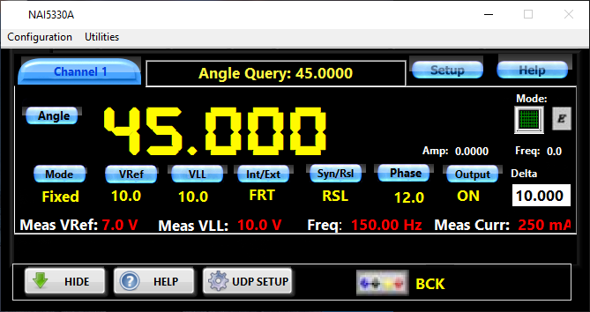

This instrument performs the synchro-resolver single channel signal simulation. The soft panel application was developed with consideration of minimization of the end-user learning curve and resembles full functionalities and the look of the physical instrument.